**********************************************************************************

**Agile Methodology all in one**

**********************************************************************************

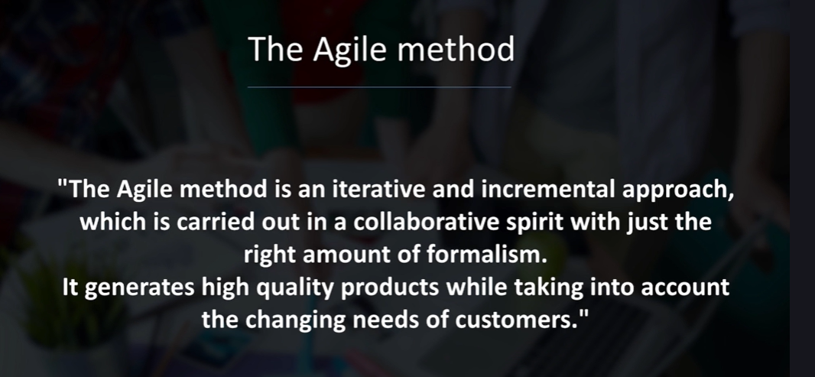

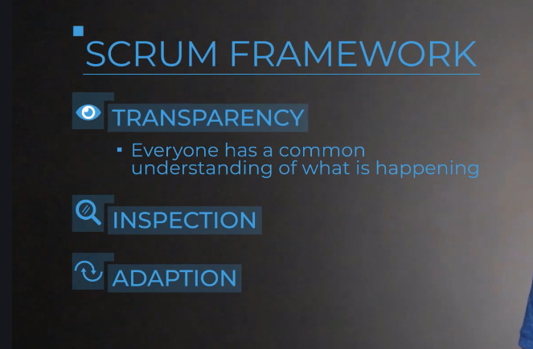

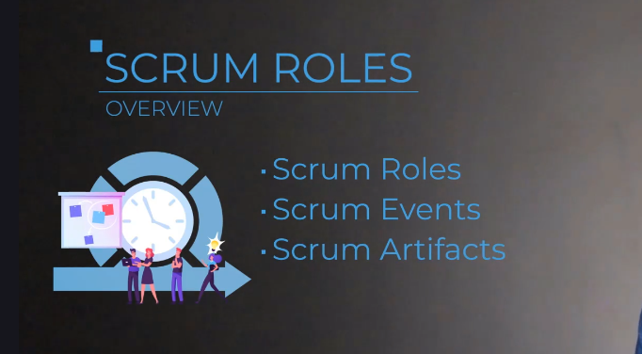

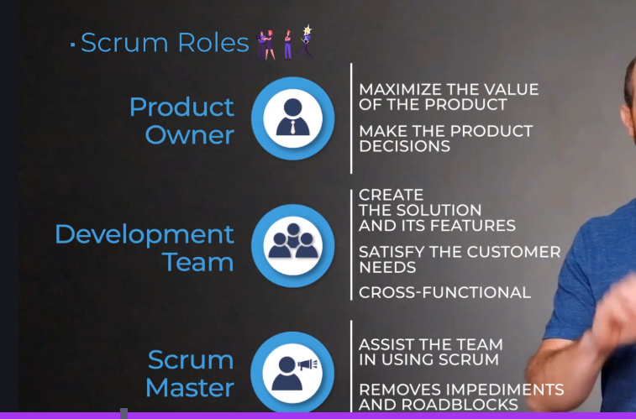

**Updates to Scrum Standards**

Scrum is the most popular Agile framework used within organizations today. In 2020, Scrum.org - the creator of Scrum standards - published an updated standards guide. While the changes to the guide are mostly verbiage (wording), it is important to understand them.

In this lecture, I am going to provide you with a quick breakdown of those changes.

**OVERVIEW:**

* The guide has been simplified tofocus more on the ***Why and What?***versusthe ***How?***
* **Reduced usage of IT and software-specific language** to increase accessibility by other teams

**SUMMARY OF CHANGES:**

* ***Development Team*** is now***Developers***to make the Scrum Team feel more inclusive, rather than two different "teams".
* ***Roles*** are now referred to as***Accountabilities*** so as to not prescribe titles roles, but rather tasks and accountabilities to enable the end result.
* Scrum Masters are no longer ***Servant leaders***but are ***True leaders***. This emphasizes now that the Scrum Master can lead from within to enable forward progress.
* Scrum Teams are now ***Self-managing***rather than ***Self-organizing***. Same concept here, just rewording to more clearly state how it is decided "who, how, and what to work on".
* Scrum Team now focuses on and iterates each Sprint toward the ***Product Goal***, which provides the desired future state of the product.

In the end, Scrum is still Scrum. It is still a lightweight framework to solve complex problems and deliver value. But this updated guide helps to simplify the language used to enable accessibility and applicability to a larger audience.

I hope this breakdown helps and I wish you nothing but success!

Happy learning,  
Jeremy, The BA Guide

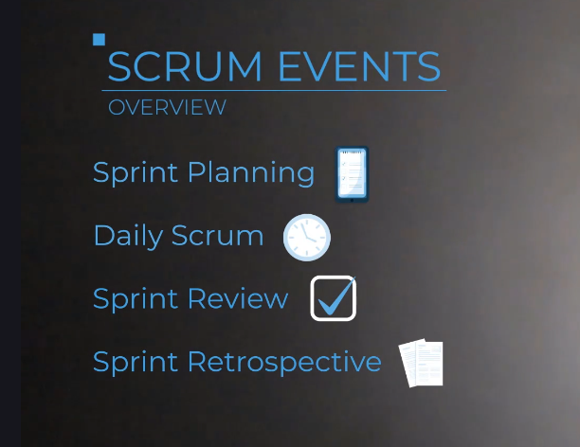





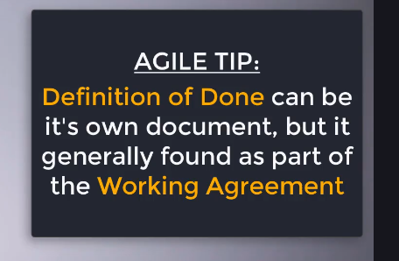

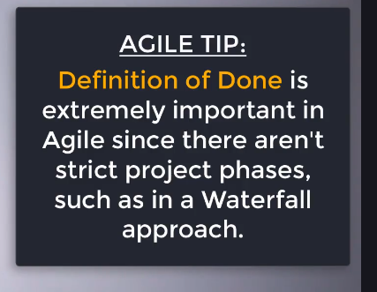

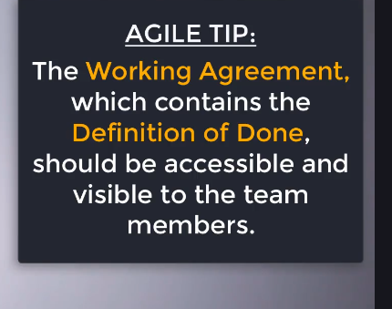



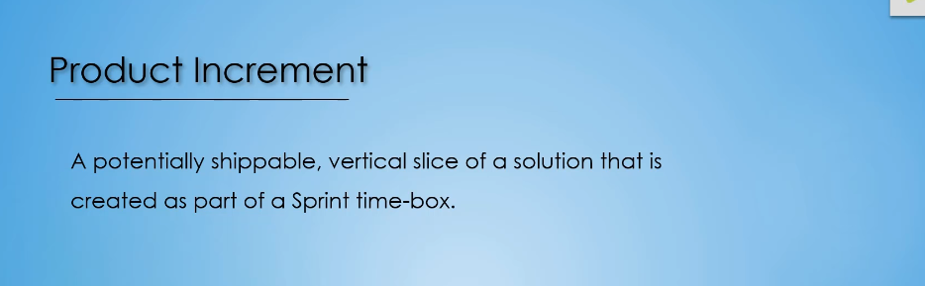

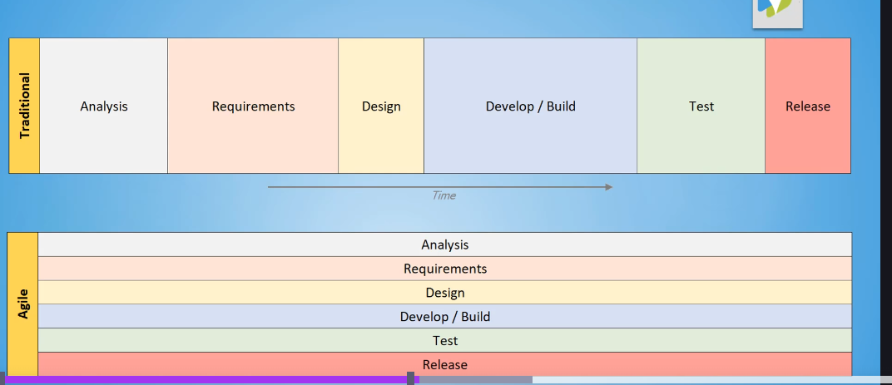

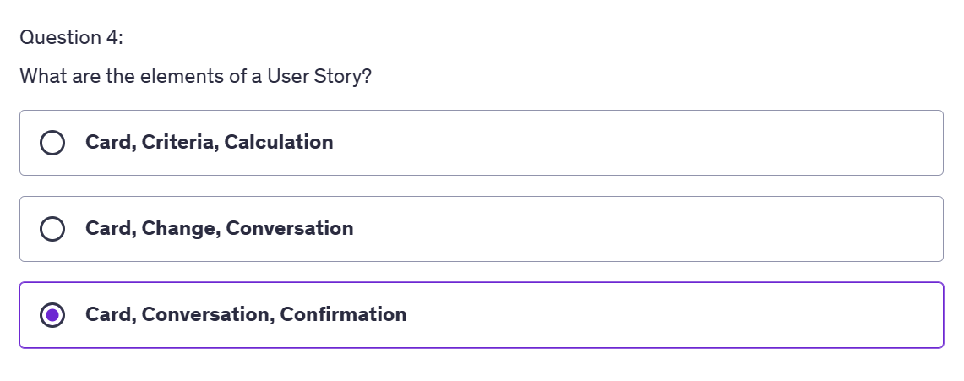

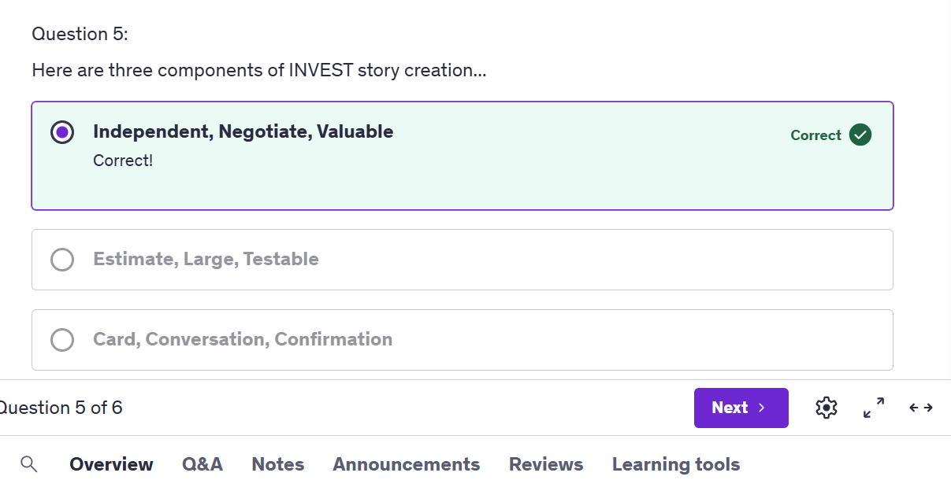

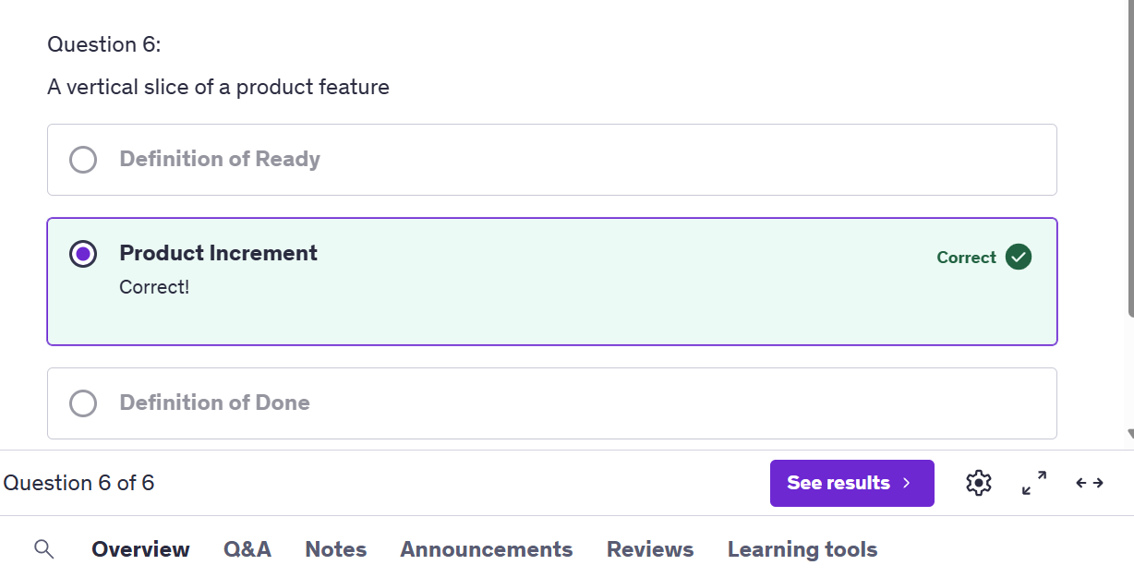

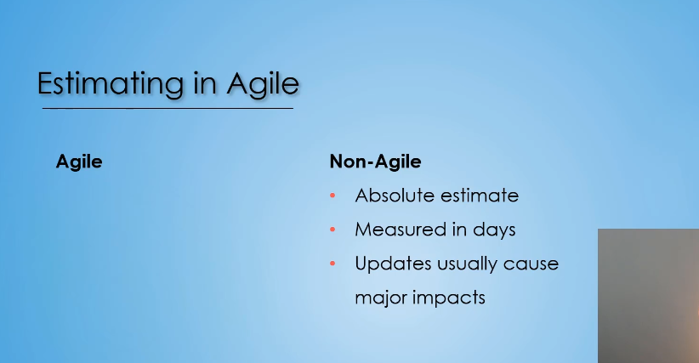

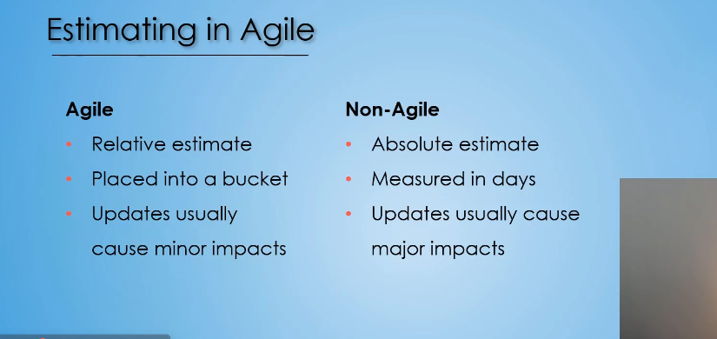

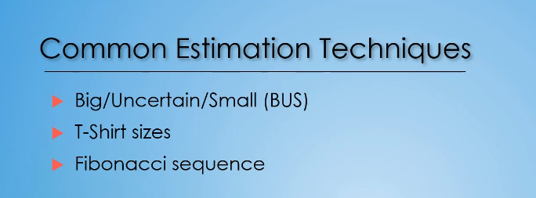

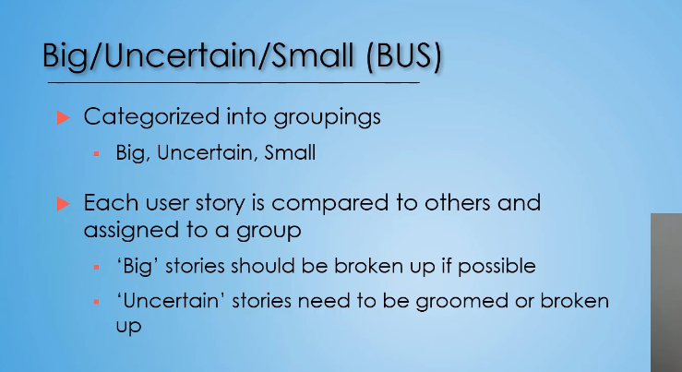

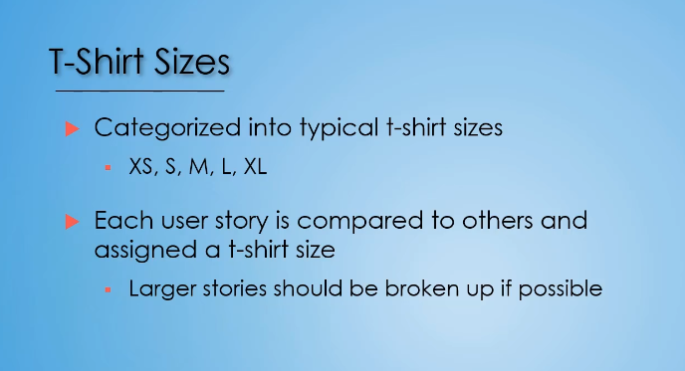\

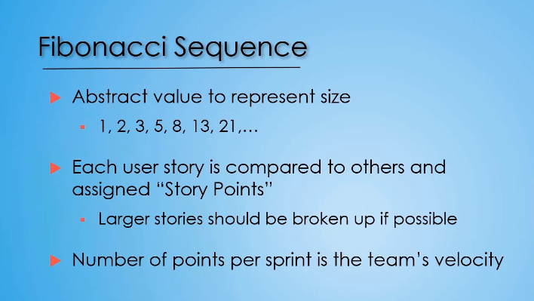

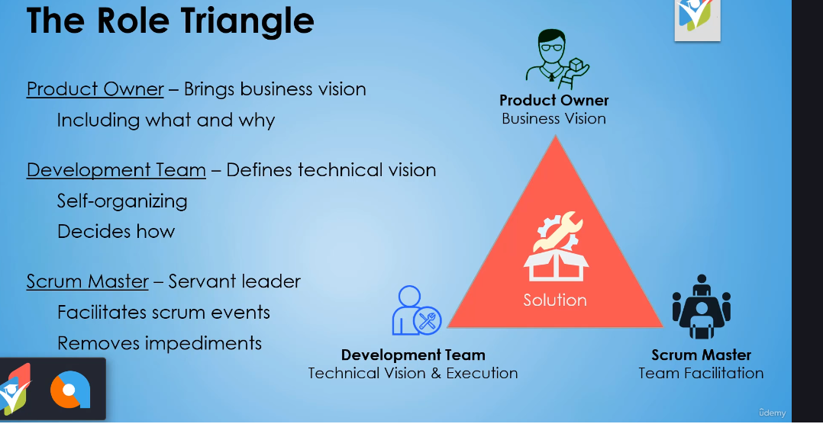

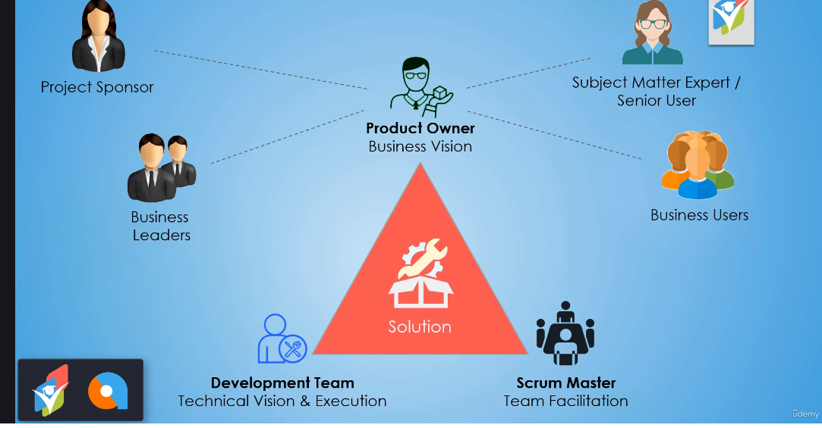

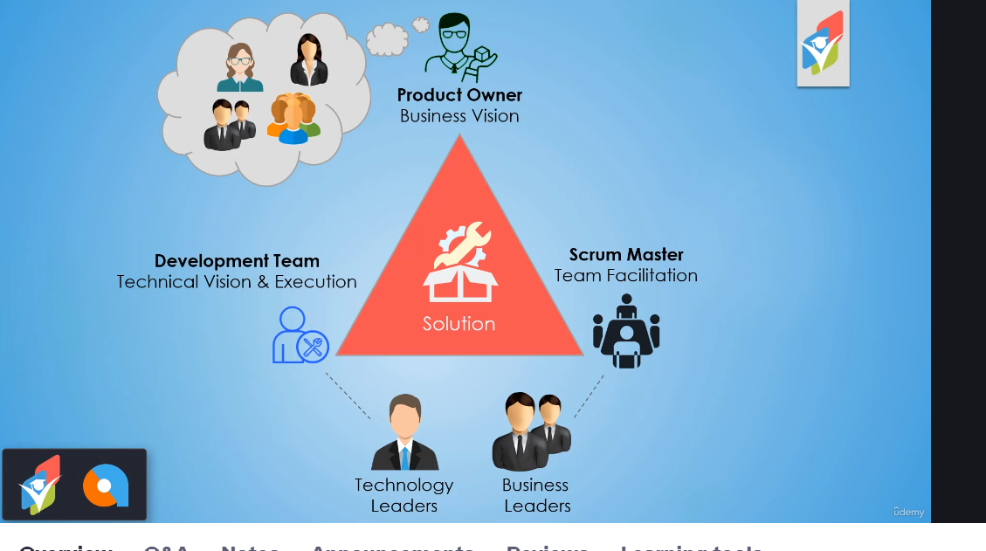

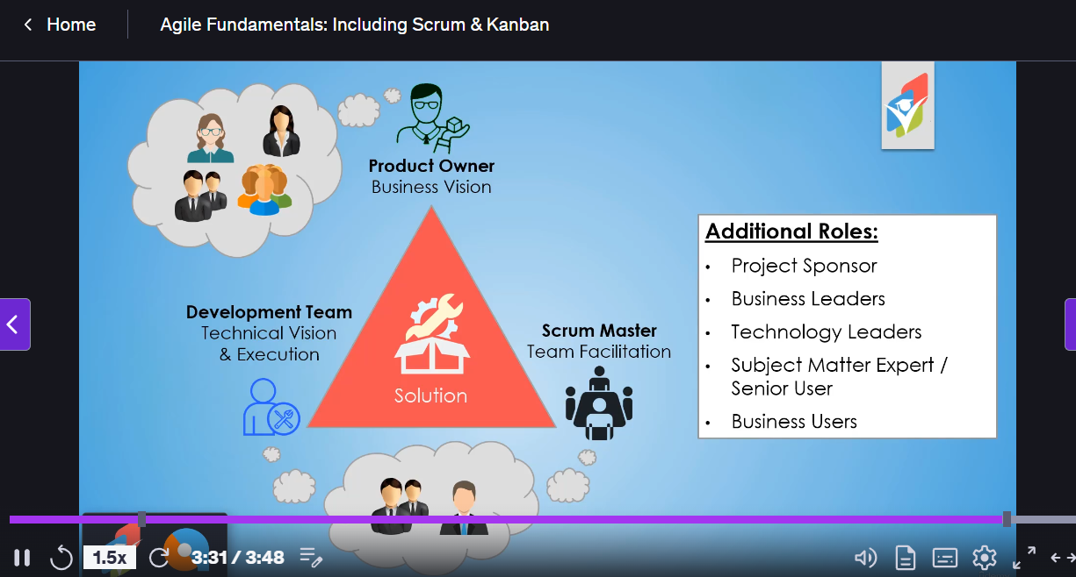

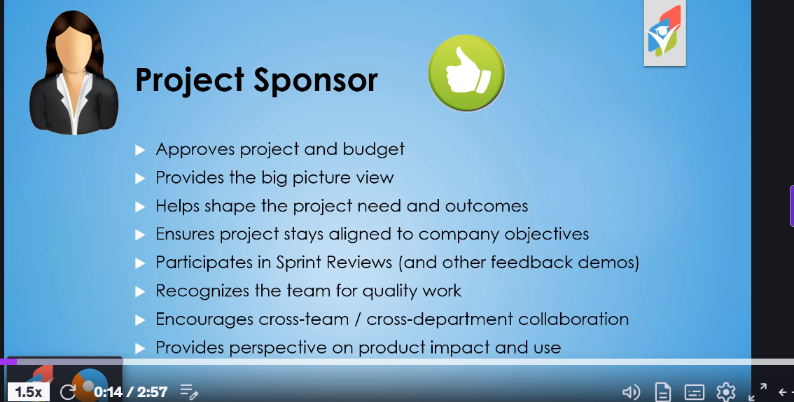

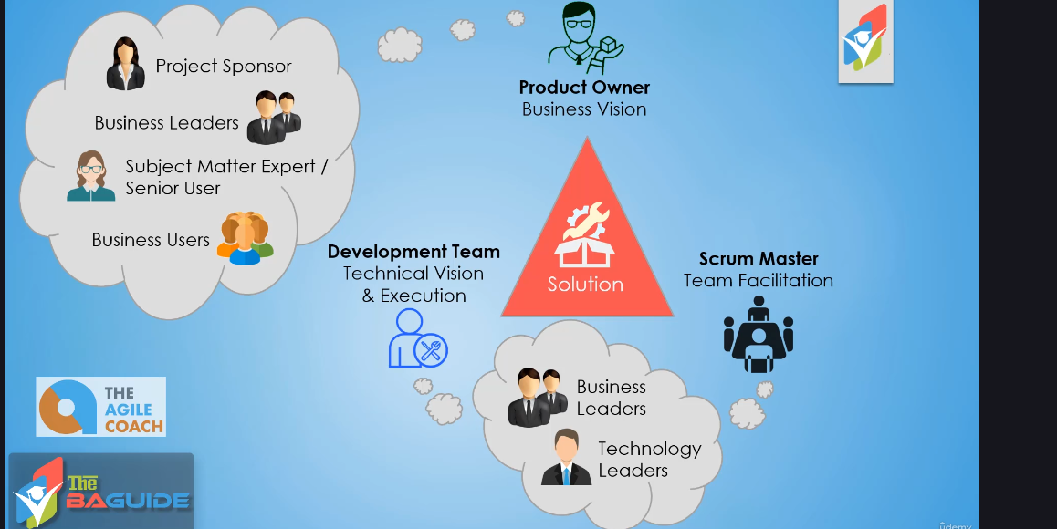

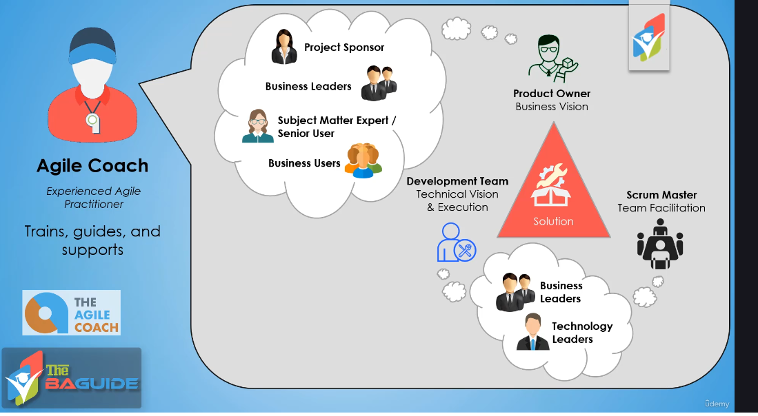

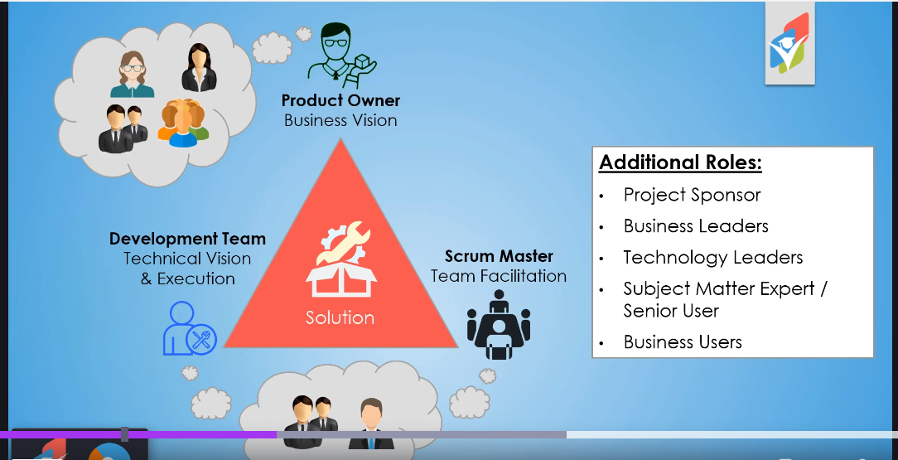

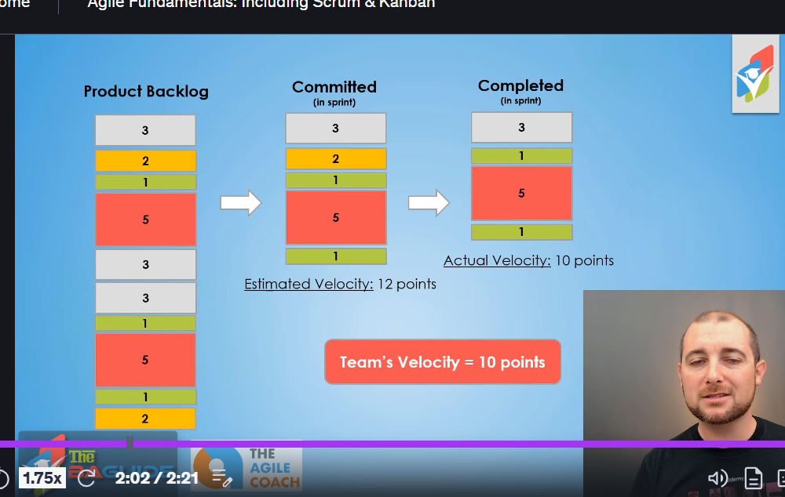

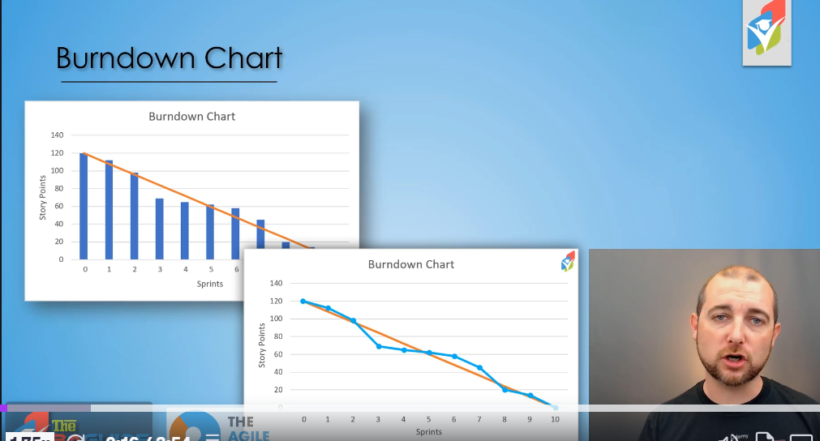

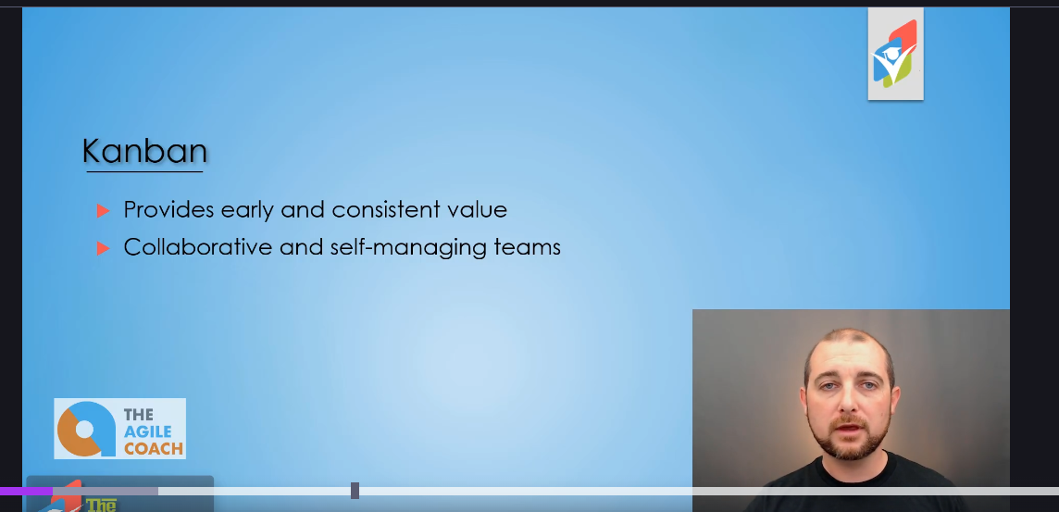

*********************************************************************************

BA-work in project

*********************************************************************************

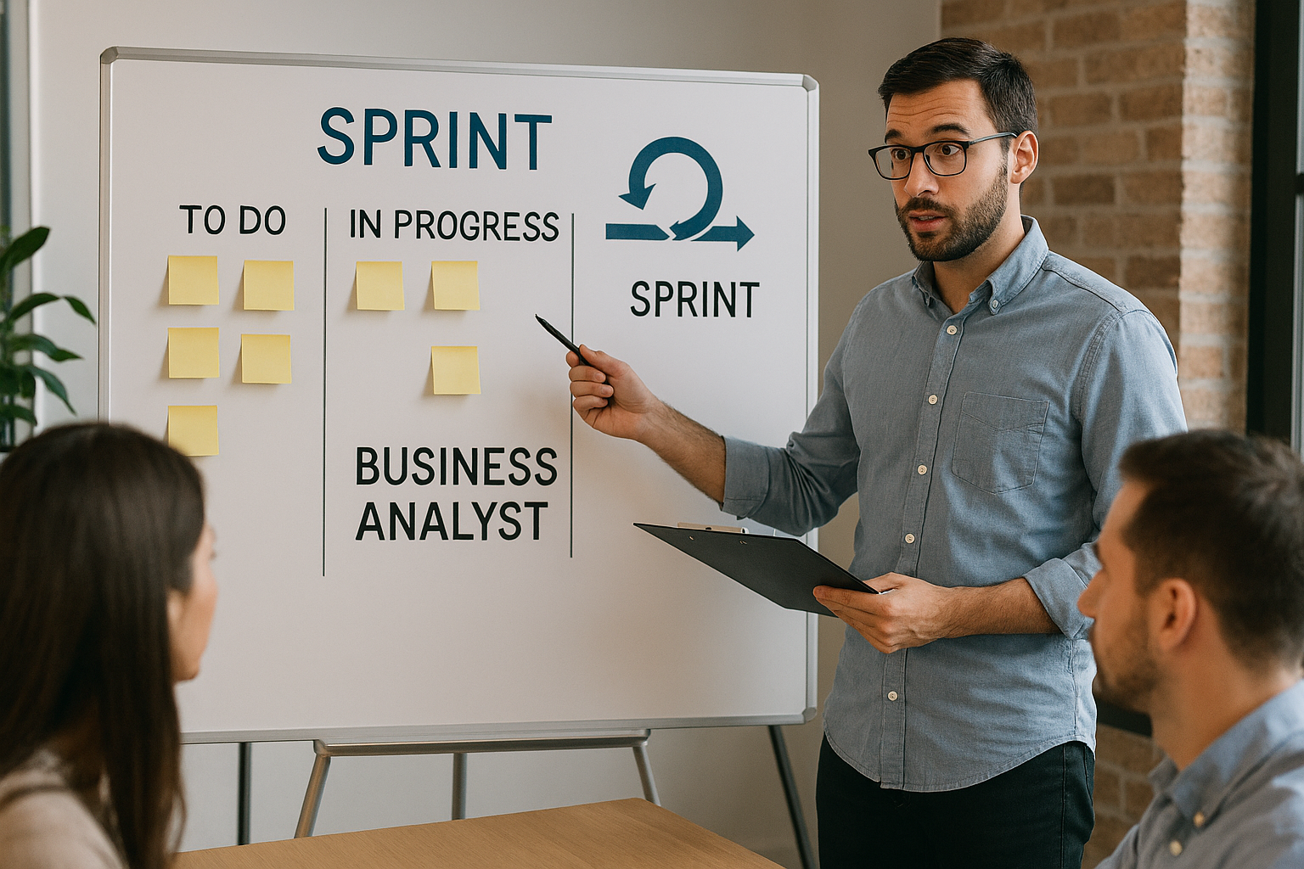

Here’s the image illustrating a **Business Analyst working within a development team in an Agile framework**. It shows:

* A **Sprint board** divided into columns like **To Do**, **In Progress**, and a section labeled **Business Analyst**.
* Sticky notes representing tasks or user stories.
* A person pointing to the board, explaining the workflow, which emphasizes collaboration and transparency in Agile.

**✅ Agile Team Diagram with Roles**

* **Center:** Sprint board with columns: *To Do*, *In Progress*, *Done*.
* **Roles around the board:**
  + **Business Analyst (BA):** Near the board, clarifying requirements and user stories.
  + **Developers:** Positioned on one side, working on tasks in *In Progress*.
  + **Testers (QA):** Near *Done* column, validating completed stories.
  + **Product Owner (PO):** Close to BA, prioritizing backlog and ensuring business value.
  + **Scrum Master:** Facilitating, ensuring no impediments, possibly standing near the team.
* **Visual elements:** Sticky notes, sprint cycle icon, laptops, collaborative posture

******************************************************************************

**Technical Architect**

******************************************************************************

Here’s a **comprehensive Role and Responsibilities document for a Technical Architect in an Agile Development Team**:

**Role: Technical Architect**

The Technical Architect is responsible for designing and overseeing the technical aspects of software development within an Agile framework. They ensure that the architecture aligns with business goals, scalability, security, and maintainability while supporting rapid delivery cycles.

**Key Responsibilities**

**1. Architectural Design & Governance**

* Define and maintain the **overall system architecture** and ensure it aligns with enterprise standards.
* Create **high-level and detailed design documents**, including diagrams for system components, integrations, and data flows.
* Establish **coding standards, design patterns, and best practices** for the development team.
* Ensure **non-functional requirements** (performance, scalability, security, reliability) are addressed in the architecture.

**2. Collaboration & Communication**

* Work closely with **Product Owners, Scrum Masters, and Development Teams** to translate business requirements into technical solutions.
* Participate in **backlog refinement, sprint planning, and daily stand-ups** to provide technical guidance.
* Act as a **bridge between stakeholders and developers**, ensuring clarity on technical feasibility and constraints.

**3. Technical Leadership**

* Guide developers on **implementation strategies**, frameworks, and tools.
* Conduct **code reviews** and ensure adherence to architectural principles.
* Mentor team members on **technical skills and best practices**.

**4. Agile Alignment**

* Support **incremental delivery** by designing modular and flexible architectures.
* Adapt architecture to accommodate **changing requirements** and **continuous integration/continuous deployment (CI/CD)** pipelines.
* Promote **DevOps practices**, including automation, monitoring, and deployment strategies.

**5. Risk Management**

* Identify **technical risks** early and propose mitigation strategies.
* Ensure compliance with **security standards and regulatory requirements**.
* Monitor **technical debt** and recommend refactoring when necessary.

**6. Innovation & Continuous Improvement**

* Stay updated with **emerging technologies** and recommend adoption where beneficial.
* Drive **proof-of-concepts (POCs)** for new tools or frameworks.
* Continuously improve architecture for **performance optimization** and **cost efficiency**.

**7. Documentation & Knowledge Sharing**

* Maintain **architecture documentation** in a centralized repository.
* Conduct **technical workshops and knowledge-sharing sessions** for the team.

**Key Skills & Competencies**

* Strong expertise in **system design, microservices, cloud platforms (AWS/Azure/GCP)**.
* Proficiency in **Agile principles**, CI/CD, and DevOps practices.
* Excellent communication and leadership skills.
* Ability to balance **technical depth with business priorities**.

**********************************************************************************

**Technical Lead-role and Responsibilities**

**********************************************************************************

**Role: Technical Team Lead**

The Technical Team Lead acts as a bridge between the development team and stakeholders, ensuring technical excellence, team productivity, and alignment with Agile principles. They provide leadership, guidance, and hands-on support to deliver high-quality software solutions.

**Key Responsibilities**

**1. Team Leadership & Coordination**

* Lead and mentor the development team, fostering collaboration and continuous improvement.
* Facilitate **daily stand-ups, sprint planning, and retrospectives** in coordination with the Scrum Master.
* Ensure team members understand **user stories, acceptance criteria, and technical tasks**.

**2. Technical Guidance**

* Provide **technical direction** on architecture, design patterns, and coding standards.
* Assist in **estimating effort** for backlog items and ensure realistic commitments.
* Support developers in resolving **complex technical challenges**.

**3. Agile Delivery**

* Ensure **incremental delivery** of features within sprint timelines.
* Promote **test-driven development (TDD), continuous integration (CI), and continuous deployment (CD)** practices.
* Collaborate with Product Owner to clarify requirements and prioritize backlog.

**4. Quality Assurance**

* Conduct **code reviews** and enforce best practices.
* Ensure compliance with **security, performance, and scalability standards**.
* Monitor and manage **technical debt**.

**5. Communication & Stakeholder Management**

* Act as a **technical point of contact** for stakeholders and other teams.
* Communicate progress, risks, and dependencies effectively.
* Align technical decisions with **business objectives**.

**6. Risk & Issue Management**

* Identify and mitigate **technical risks** early.
* Resolve blockers impacting sprint progress.
* Ensure contingency plans for critical components.

**7. Continuous Improvement**

* Encourage **innovation and adoption of new technologies**.
* Conduct **knowledge-sharing sessions** and technical workshops.
* Drive improvements in **development processes and tools**.

**Key Skills & Competencies**

* Strong expertise in **software development, Agile practices, and DevOps**.
* Excellent **leadership, communication, and problem-solving skills**.
* Ability to balance **technical depth with delivery priorities**.

********************************************************************************

**Test manager and team**

********************************************************************************

**Role: Test Manager in Agile**

The Test Manager ensures quality across the Agile development lifecycle by defining testing strategies, coordinating test activities, and enabling continuous delivery of high-quality software. Unlike traditional models, the Test Manager in Agile focuses on **collaboration, automation, and continuous feedback** rather than heavy documentation.

**Key Responsibilities of Test Manager**

**1. Test Strategy & Planning**

* Define **Agile-aligned test strategy** covering functional, integration, performance, and security testing.
* Ensure testing is integrated into **sprint planning and backlog refinement**.
* Identify **test environments, tools, and automation frameworks**.

**2. Quality Governance**

* Establish **quality metrics** and monitor adherence.
* Ensure compliance with **regulatory and security standards**.
* Manage **risk-based testing** and prioritize critical areas.

**3. Collaboration & Communication**

* Work closely with **Product Owner, Scrum Master, and Development Team** to clarify acceptance criteria.
* Participate in **daily stand-ups, sprint reviews, and retrospectives**.
* Act as a **bridge between QA team and stakeholders** for quality updates.

**4. Automation & Continuous Testing**

* Drive **test automation strategy** for regression and integration tests.
* Ensure tests are part of **CI/CD pipelines** for continuous feedback.
* Promote **shift-left testing** (early involvement in development).

**5. Team Leadership**

* Mentor QA team members on **Agile testing practices**.
* Allocate resources and manage workload across sprints.
* Encourage **cross-functional skills** (e.g., developers writing unit tests).

**6. Defect Management**

* Ensure **quick defect triage and resolution** during sprints.
* Track and report **defect trends and root cause analysis**.

**7. Continuous Improvement**

* Conduct **retrospectives for QA processes**.
* Introduce **new tools and techniques** for better coverage and efficiency.
* Promote **exploratory testing and risk-based approaches**.

**Role of Testing Team in Agile**

**Responsibilities**

* Collaborate with developers and product owners to **define acceptance criteria**.
* Write and execute **test cases and automated scripts**.
* Perform **functional, integration, and exploratory testing** within sprints.
* Validate **user stories and deliverables** against business requirements.
* Participate in **pair testing and continuous feedback loops**.
* Ensure **test coverage for new features and regression areas**.

**Key Skills for Test Manager & Team**

* Strong knowledge of **Agile principles and testing frameworks**.
* Expertise in **automation tools (Selenium, Cypress, etc.)**.
* Familiarity with **CI/CD tools (Jenkins, Azure DevOps)**.
* Excellent communication and collaboration skills.

*********************************************************************************

**Project JIRA’s user stories lifecycle**

*******************************************************************************

In **Agile methodology**, Jira workflows typically represent the lifecycle of a task or user story. Here’s a **common set of states** you can use for an Agile project:

**✅ Typical Jira Workflow States in Agile**

1. **To Do**
   * The task/user story is created and ready to be picked up.
   * No work has started yet.
2. **In Progress**
   * Development work is actively happening.
   * Assigned to a developer.
3. **Ready for Code Review** *(optional but common)*
   * Development is complete, waiting for peer review.
4. **Code Review Complete / Ready for Test**
   * Code has passed review and is deployed to a test environment.
   * QA team can start testing.
5. **Testing In Progress**
   * QA team is validating functionality against acceptance criteria.
   * Includes functional, integration, and regression testing.
6. **Test Complete / Ready for Release**
   * QA has signed off.
   * The feature is ready for deployment to production.
7. **Done / Completed**
   * The task is fully delivered and accepted by the Product Owner.
   * Meets Definition of Done (DoD).

**Optional States for Agile Projects**

* **Blocked** – Work cannot proceed due to dependency or issue.
* **On Hold** – Temporarily paused.
* **Ready for Deployment** – After testing, waiting for production release.

**Best Practice**

* Keep workflow **simple and aligned with Agile principles**.
* Use **Definition of Ready (DoR)** and **Definition of Done (DoD)** for clarity.
* Automate transitions where possible (e.g., moving to “Ready for Test” after merging code).

**********************************************************************************

Here’s the **complete lifecycle of a Jira User Story in Agile methodology, stage by stage**:

**✅ Jira User Story Lifecycle in Agile**

**1. Backlog**

* **Status:** *Backlog*
* The user story is created and stored in the **Product Backlog**.
* Not yet prioritized for development.

**2. Selected for Development**

* **Status:** *To Do*
* The story is prioritized and moved to the **Sprint Backlog** during sprint planning.
* Meets **Definition of Ready (DoR)**.

**3. In Progress**

* **Status:** *In Progress*
* Development work starts.
* Developers implement functionality based on acceptance criteria.

**4. Code Review (Optional)**

* **Status:** *Ready for Code Review / Code Review*
* Code changes are reviewed by peers for quality and compliance.

**5. Ready for Testing**

* **Status:** *Ready for Test*
* Development is complete, and the story is deployed to a test environment.
* QA team begins validation.

**6. Testing In Progress**

* **Status:** *Testing / QA In Progress*
* QA executes functional, integration, and regression tests.
* Defects are logged and fixed within the sprint.

**7. Test Complete**

* **Status:** *Test Complete / Ready for Release*
* QA signs off after successful testing.
* Meets **Definition of Done (DoD)**.

**8. Done**

* **Status:** *Done / Completed*
* The story is accepted by the Product Owner.
* Ready for production deployment or already released.

**Optional States**

* **Blocked** – Waiting on dependency or issue.
* **On Hold** – Temporarily paused.
* **Ready for Deployment** – After QA sign-off, waiting for production release.

**********************************************************************************

**Defect Lifecycle for testing**

**********************************************************************************

Here’s the **Defect Lifecycle for Test Team and Developers in Jira under Agile methodology**:

**✅ Defect Lifecycle in Agile (Jira)**

**1. New / Open**

* **Who:** QA Team
* Defect is logged during testing of a user story.
* Includes details: steps to reproduce, screenshots, environment, severity, priority.

**2. Assigned**

* **Who:** Developer
* Defect is assigned to a developer for fixing.
* Developer analyzes the root cause.

**3. In Progress**

* **Who:** Developer
* Developer starts working on the fix.
* Status changes to *In Progress*.

**4. Code Fix Complete**

* **Who:** Developer
* Fix is implemented and unit tested.
* Status changes to *Ready for Test* or *Fixed*.

**5. Ready for Test**

* **Who:** QA Team
* QA validates the fix in the test environment.
* Executes regression tests if needed.

**6. Verified**

* **Who:** QA Team
* QA confirms the defect is resolved.
* Status changes to *Closed* or *Done*.

**7. Reopened (Optional)**

* If the defect persists or fix fails, QA reopens it.
* Goes back to *Assigned* for rework.

**Optional States**

* **Deferred** – Fix postponed to a later sprint.
* **Rejected** – Defect is invalid or not reproducible.
* **Duplicate** – Already logged.

**Key Agile Principles for Defect Lifecycle**

* Defects are treated as **work items in the sprint**.
* Fixes should happen **within the same sprint** whenever possible.
* QA and Dev collaborate closely to minimize cycle time.

*******************************************************************************